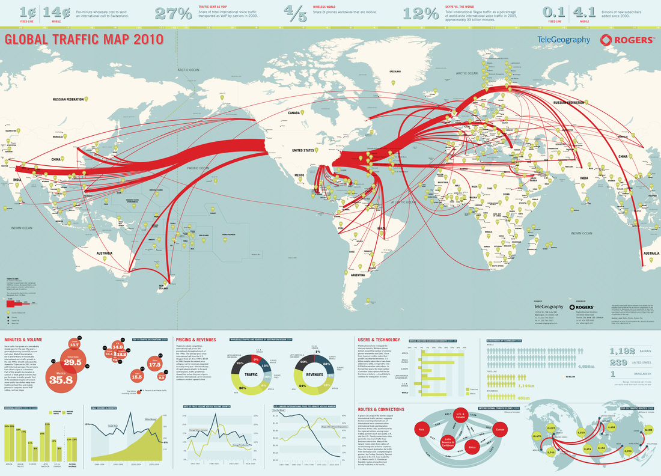**Global Traffic map 2010 – telephones**